Chapter 18, Problem 23.

If the Fourier transform of f(t) is

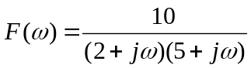

determine the transforms of the following:

- f(-3t)
- f(2t-1)
- f(t) cos 2t
- 
 